**VIDEO CARD**

* **PCI Express**
* **AGP**
* **PCI**

PCI Express is the most current, and fastest, of the video cards. If possible, you will likely want to install a PCI express video card. Figure 5.1 shows a PCI Express video card.

**Figure 5.1: An PCI Express Video Card**  
  
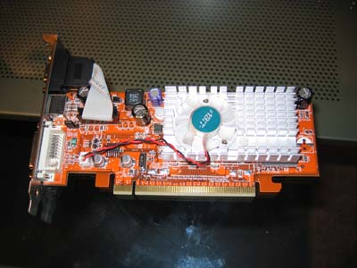

Before PCI express the most common type of video card was the AGP card. AGP cards still give great performance. If you have only one video card in your system you will want to make sure it is either AGP or PCI Express. Figure 5.2 shows an AGP video card.

**Figure 5.2: An AGP Video Card**  
  
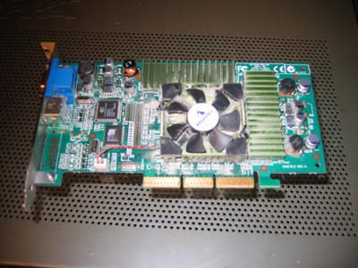

The oldest style for video cards that I will discuss is PCI. You can see a PCI video card in Figure 5.3.

**Figure 5.3: A PCI Video Card**  
  
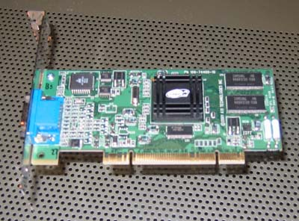

You should not use a PCI card as your primary video display card. PCI cards are to slow to play any of the more advanced video games, or to show video. Besides, the price difference between PCI and AGI/PCI-Express is minimal.

What is a good option for PCI cards is using them in conjunction with an AGP or PCI-Express video card. This allows you to have a second display. This will be covered in the next section. Now I am going to show you how to install the video card.